El Museo Del Barrio

Student’s Name
Institution
Course
Instructor’s Name
Date

El Museo Del Barrio
I chose this place because it serves the Latino speaking community by preserving its culture and arts of all Latinos and Puerto Rican people in the United States. The place has a sentimental value to the Latino community. It was created by Raphael Montanez Ortiz with Puerto Rican parents, tutors, community activists as well as artists in 1969 to counteract other museums that ignored Latino artists (El Museo.org, 2020). Notably, it was birthed during the civil war period where the minorities were fighting for their rights to be represented and accepted in the United States together with African Americans. Therefore, since its establishment, El Museo Del Barrio has promoted and celebrated the Latino culture through festivals that showcase its colorful customs and special events.
El Museo Del Barrio is located at heart of New York City, and it is the only museum with the Latino heritage. El Museo Del Barrio serves as an educational center to all members of its community, including people who are not Latinos and are interested in learning about Latino heritage.
The museum educates the community by using a public program that is designed to reach the interested parties. For instance, El Museo Del Barrio has programs specialized for families that offer them a chance to explore and learn about Latina America heritage; they achieve this by factoring in new themes every month. They use dance performances, live music, and a bilingual screening of classic Latino American films. El Museo Del Barrio uses scholarly symposiums and lectures to educate the community about its heritage (Cullen, 2018). Besides, since over 40% of the public school population in New York City is Latino based, the museum serves as a place where students from these schools are taught about the art heritage through guided tours. Educators lead the tours. Workshops that provide students with different activities, such as music or art, are built based on hands-on experience and observation skills in a studio. What they get to learn in this museum is part of their school’s curriculum. They also hold special events that incorporate the Spanish language using songs that are accessible to English speakers. Here, families learn about El Dia de los Muertos which means day of the dead customs from the family celebrations hosted by the museum in November (NYC Arts, 2011).
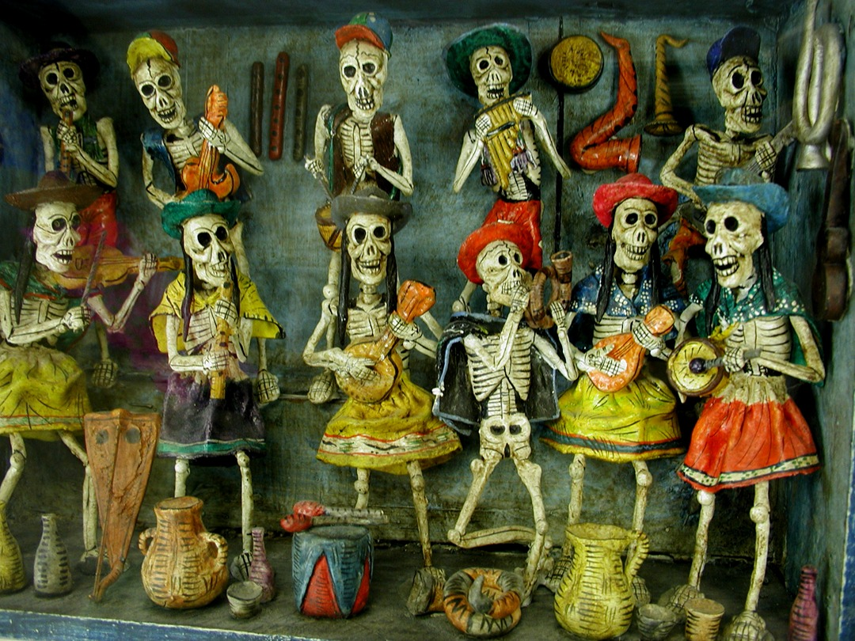
Artifacts for Dia de los Muertos to commemorate day of the dead

What I can recommend about El Museo Del Barrio are their programs. The programs created by the art educators of the Latino heritage are great because they present their culture using live music depicting the nature of their culture using catchy tunes in the Spanish language. The live performances have a lasting impression on individuals, and it becomes hard for them to depart from such events. Additionally, I would recommend the family programs as well, where family members and their children get to learn about the importance of celebrating the day of the dead while exploring culture and arts of their heritage.
The one specific new task I have learned is that before the museum was established in 1969 by Ortiz and his colleagues, he was a high school teacher at an Arts and Music school (Hackshaw, 2017). He mobilized the school’s officials to start catering for the needs of African American and Puerto Rican students that attended the school. Because of his resilience on this matter, he was appointed as a custodian of the educational program catering for the Puerto Rican art, history, and culture of the school.

References
Cullen, D. (2018). Somehow Exceptional: El Museo del Barrio, New York. In Art Museums of Latin America (pp. 192-204). Routledge.
El Museo.org. (2020). History & Mission. https://www.elmuseo.org/history-mission/
Hackshaw, W. (2017, June 22). El Museo del Barrio and the Act of Preserving Memory and a Culture. Latino Rebels. https://www.latinorebels.com/2017/06/21/el-museo-del-barrio-and-the-act-of-preserving-memory-and-a-culture/
NYC Arts. (2011, November 28). El Museo Del Barrio - NYC-ARTS. NYC. https://www.nyc-arts.org/organizations/299/el-museo-del-barrio

